Jurnal Borneo Administrator
Volume xx (x) 20xx: xx-xx
P-ISSN: 1858-0300, E-ISSN: 2407-6767
DOI: 10.24258/jba.xxxxx.xxx
Accredited by Kemenristek/BRIN No. 148/M/KPT/2020
article

Please Type The Title of Paper Here

First Author^{1*} and Second Author²

¹First author’s affiliation/institution, City, Country
²Second author’s affiliation/institution, City, Country

How to cite: … [Filled by Editor]

Article History  Received: …  Accepted: …  [Filled by Editor]  Keywords:  Keywords contain three to five separate words/ phrases. Press the enter key after each keyword.  Keyword 1;  Keyword 2;  Keyword 3 | ABSTRACT  Type your abstract here not more than 250 words. The abstract should be brief and consists of some elements, includes: Background, Aim, Method, Finding, and Conclusion. The abstract is presented separately from the main article, so it must be able to stand alone. For this reason, citations should be avoided. Furthermore, non-standard or uncommon abbreviations should be avoided, but if essential they must be defined at their first mention in the abstract itself.

- INTRODUCTION
Please use this Template to prepare your manuscript and do not alter or change the format. Manuscript in English is preferred. Should you have any question regarding the Template or manuscript’s format, please contact the Editor. The manuscript’s length should be within 6000-7000 words totally (references included). Use effective and concise sentences, and avoid writing redundant sentences in your manuscript.
In the Introduction section, state the objectives of the work and provide an adequate background, avoiding a detailed literature survey or a summary of the results. Explain how you addressed the problem in the field and clearly state the specific aims of your study.

- LITERATURE REVIEW
This section presents a review of previous researches or literatures which discuss relevant theme. It is recommended to discuss new literatures from journal, proceeding, thesis or dissertation (with minimum 10 years references)..
Citations can appear in narrative form or in full parentheses. In a narrative citation, the author's name appears as part of the sentence. The year of publication can be separated in parentheses after the author's name or integrated into the sentence. As for citations in parentheses, the author's last name and year of publication appear together in parentheses. Parenthetical citations are usually placed at the end of the sentence.
Example of writing citations: This is in line with Choi's (2019) opinion that FWA studies in the context of the public sector are still relatively new whichare still developing, or the idea of implementing FWA in a number of countries has actually developed since the 1950s which at that time used the term telework (Siddhartha & Malika, 2016).
Citations of a reference with one credited author include the author’s surname and the publication year. Citations of a reference with two credited authors include the surnames of both authors and the publication year. The surnames are separated by “&” in narrative citations and by an ampersand (“&”) in parenthetical citations. Citations of a reference with three credited authors include the surname of the first author, followed by “et al.” and the publication year.

- METHOD
In the Method section, state what the method or approach was used in the study, how the data was collected, and how it was analyzed.

- RESULT AND DISCUSSION
The result should be clear and brief. It presents logical presentation of the data and/or information. Factual description of the data describes what the study found.
The Discussion should explore the significance of the results/findings of the work, not repeat them. It should present a summary of findings, interpretation upon the data, the similarities/differences, unexpected/negative results, and analysis based on the certain theory, approach and/or concept.
All citations must be completed with their sources, and in-text citations use run note. Citation of books should be completed with the page information. All cited sources must be presented in the references list based on APA reference style. We put concern on integrity issue in writing manuscript, and therefore plagiarism checking is applied to all manuscripts before they are approved.

Sub Section
It is allowed to make Sub Sections (if required) within each section. Author can add relevant Sub Sections and the title must be relevant with the content.

Table and Graphic
Table and graphic can be used to present numeric data. The title of the table and the graphic is put on the top, while the source is under the table or graph (see examples). It is a compulsory to put data source if author puts the table or the graphic in the manuscript.

Table 1. Number of Poor People in Indonesia in 2018 (thousand)
 | First Semester  (March) | Second Semester (September)
Urban | 10,144.37 | 10,131.28
Rural | 15,805.43 | 15,543.31
Total | 25,949.80 | 25,674.59
Source: BPS (2019)

Graph 1. Number of Poor People in Indonesia 2018 (thousand)

Source: BPS (2019)

Figure/Picture and Photograph
Figure/picture and photograph can be presented to provide any information in visual form. The title is put under the figure/picture or photograph. Each them should be completed by the source if it was taken from any source or credit information if it is owned by the author.

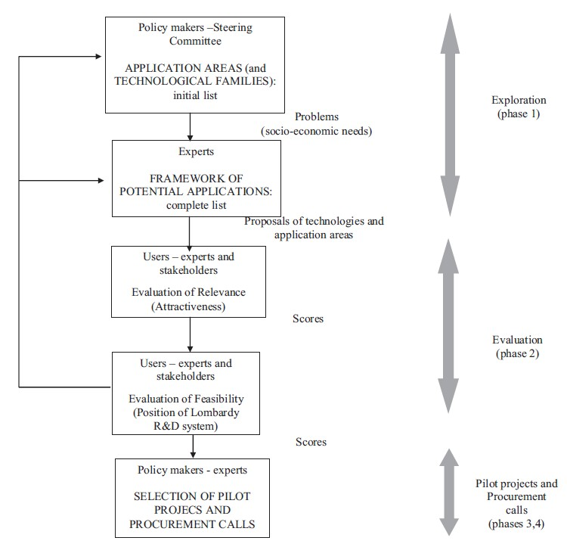
(Source: Vecchiato & Roveda (2014:102))
Figure 1. A3T Project: Methodology and Organization Process

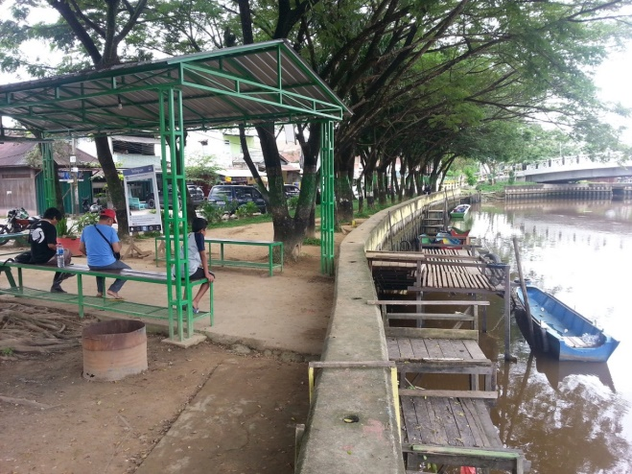
(Photo: Wahyudi (20/11/2016))
Picture 1. Port of GMSS SKM in Samarinda

- CONCLUSION
The conclusion of the study should be presented in the Conclusion section. The conclusion section should lead the reader to important matter of the paper. Present global and specific conclusions, but do not summarize the paper. The conclusions should address the problems and aims which have been stated in the Introduction.
It also can be followed by suggestion or recommendation (if any) for decision maker or further research, but it is optional.

Acknowledgement
In the Acknowledgement section, recognize those who helped Author(s) in the study, but do not qualify them as authors. List here those organizations or individuals who provided help during the research and manuscript writing (e.g., advisors, proofreaders, sponsors, etc.).

Contributorship
If the authors are more than one, the manuscript should be completed with information about the contribution of each author. Please use this sub section to describe the authors’ contributions or roles in writing the manuscript respectively.

REFERENCES
Presenting a list of reference is a compulsory. It is recommended to use a reference management software (such as Mendeley), in order to make sure that all citations are matched with the reference list. The reference should be presented in APA style. The reference guide for citing in accordance with principles established by the Publication Manual of the American Psychological Association, Seventh Edition (2020).
The references should be listed at the end of the paper, and should be listed alphabetically by author’s surname. Authors should ensure that every reference or citation in the text appears in the list of references and vice versa. Wikipedia, personal blog, or non-scientific websites are not allowed to be taken into account. It is recommended to use primary references (at least 80%) and they are update within the late ten years.
There are two types of reference source i.e. electronics sources and non-electronics sources. Several samples of correct format for various types of reference are as follows:

- Journal: Author, A., & Author, B. (year). Title of the journal article: Subtitle. Journal Title, ##(#), ####–####. https://doi.org/DOI.
Example:
Whiting, V. R., & de Janasz, S. C. (2004). Mentoring in the 21st Century: Using the Internet to Build Skills and Networks. Journal of Management Education, 28(3), 275–293. https://doi.org/10.1177/1052562903252639.

Example more than 3 authors:
Author, A. A., Author, B. B., & Author, C. C. (yyyy). Title of the journal article: Subtitle. Journal Title, ##(#), ####–####. https://doi.org/DOI

Prinzie, P., Stams, G. J. J. M., Deković, M., Reijntjes, A. H. A., & Belsky, J. (2009). The Relations Between Parents’ Big Five Personality Factors and Parenting: A Meta-Analytic Review. Journal of Personality and Social Psychology, 97(2), 351–362. https://doi.org/10.1037/a0015823

- Book: Author, A., Author, B., & Author, C. (year). Book Title. City, State or Country: Publisher.
Example:
Dwiyanto, A. (2011). Mengembalikan Kepercayaan Publik Melalui Reformasi Birokrasi. Jakarta: Gramedia Pustaka Utama.

- Chapter or book section: Author [of Chapter or Article]. (Year). Chapter or Book Section Title. In Editor (Ed.), Book (pages). City, State or Country: Publisher.
Example:
Schulze, G.G. and Sjahrir, B.S. (2014). Decentralization, Governance and Public Service Delivery. In Hill, H. (Ed). Regional Dynamics in a Decentralized Indonesia. (186-207). Singapore: Institute of Southeast Asian Studies.

- Proceeding: Author, A. A., Author, B. B., & Author, C. C. (yyyy). Title of the paper presentation: Subtitle. Serial Proceedings/Journal Title, ##(#), ####–####. https://doi.org/DOI
Example:
Nisa, H. and Afriani. (2019). Hubungan Antara Komunikasi Orangtua dan Remaja tentang NAPZA dengan Tingkat Pengetahuan terhadap NAPZA pada Remaja di Kota Banda Aceh. In Azizi Abu Bakar (Ed). Proceedings for The International Conference on Education, Islamic Studies and Social Sciences Research 2016. Banda Aceh, 23-25 July 2016 (238-250). Kedah Darul Aman: RCS Global Sincere Resources
Albright, M. (1991). The role of the United States in Central Europe. Proceedings of the Academy of Political Science, 38(1), 71–84. https://doi.org/10.2307/1173814

- Report: Author or corporate author. (Year). Report title. City: Publisher
Example:
Management Advisory Committee. (2004). Connecting Government: Whole of Government Responses to Australia’s Priority Challenges. Canberra: Commonwealth of Australia.

- Government publication: Author OR Government Name. Name of Government Agency. (Year). Title: Subtitle (Report No. xxx [if available]). Place of Publication: Publisher.
Example:
BPS. (2019). Perdagangan Antar Wilayah Indonesia 2018 (Katalog: 8201023). Jakarta: Badan Pusat Statistik

- Website: Personal or Corporate Author. (Year, Month, day). Article title. Retrieved [date] from URL of website page.
Example:
Tempo.co. (2018, June 30). Dana Otonomi Khusus dan Keistimewaan untuk Perkuat Desentralisasi. Retrieved on 25 February 2019, from https://nasional.tempo.co/read/1102254/dana-otonomi-khusus-dan-keistimewaan-untuk-perkuat-desentralisasi

